**USER’S MANUAL**

**Admin Account**

1. To create a new admin account, click the link to register.

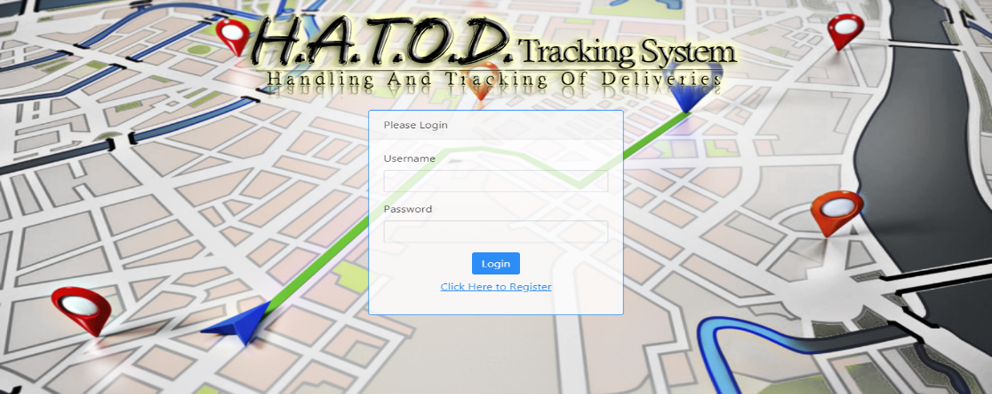

2. Input necessary details to complete the registration form, then click submit. It is required to fill up all the input fields.

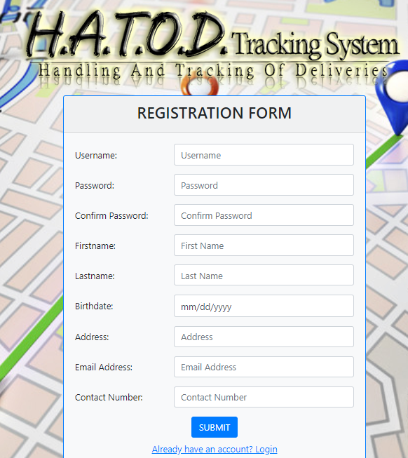

3. After registration, a validation message will be displayed and a link will redirect you to the login page. Use your credentials to login.

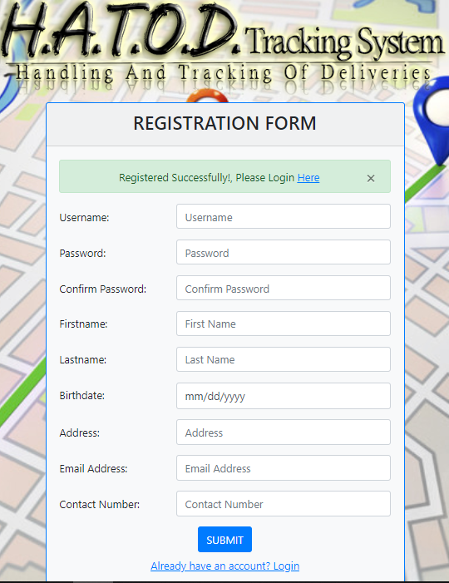

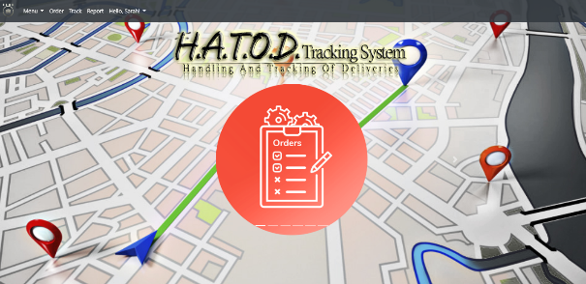4. After logging in, the admin will be redirected to a landing page, which is the Dashboard.

5. Accessing the Navigation Bar will allow the admin to add a new product, customer, personnel and vehicle through the MENU dropdown list, and also create an order, track a delivery, view reports and view an admin’s profile.

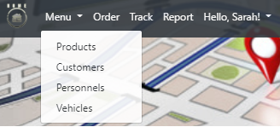

6. To add a new product, access the Menu dropdown list and click Product. The admin will be redirected to the Products’ Page.

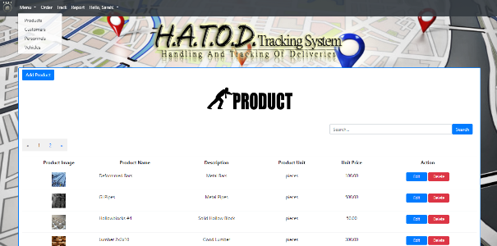

7. Clicking the “Add Product” button, displays a modal form that allows an admin to input a new product. The input fields in the form are all required.

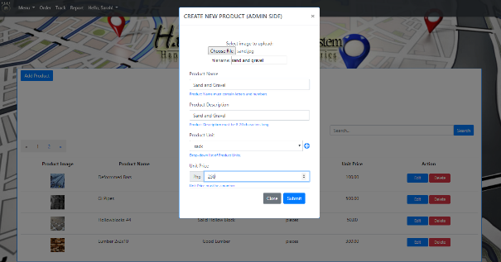

8. An admin can also add a new product type. After adding a new product, a validation message will be displayed.

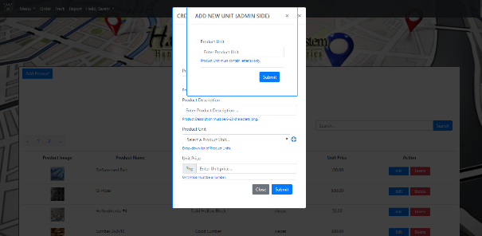

10. An admin can edit a product’s information. After editting, a validation message will be displayed.

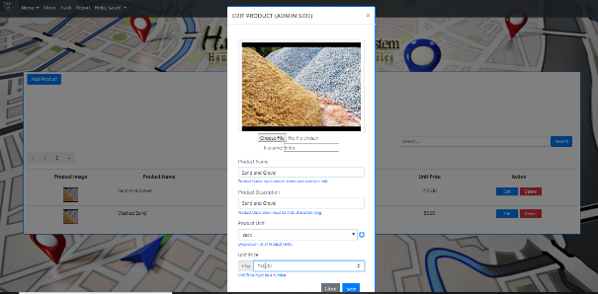

11. An admin can also delete a product.

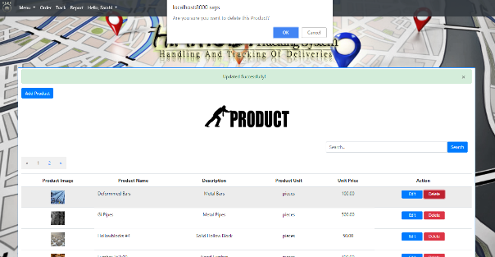

12. To add a new customer, access the Menu dropdown list and click Customers. The admin will be redirected to the Customers’ Page.

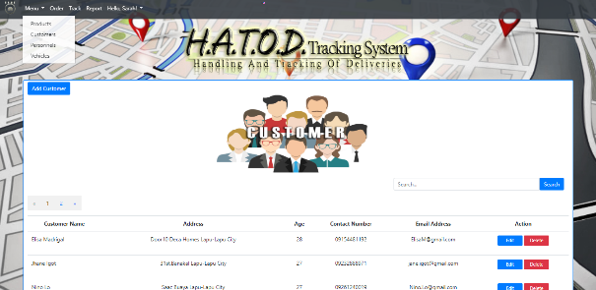

13. Clicking the “Add Customer” button, displays a modal form that allows an admin to input a new customer. The input fields in the form are all required.

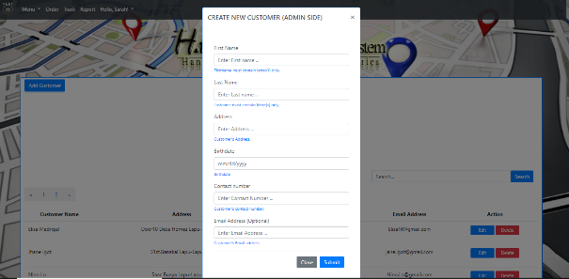

14. An admin can edit a customer’s information. After editting, a validation message will be displayed.

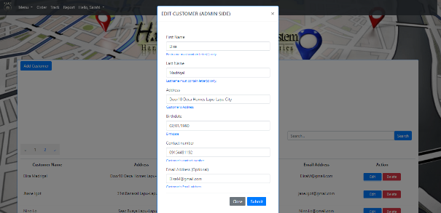

15. An admin can also delete a customer.

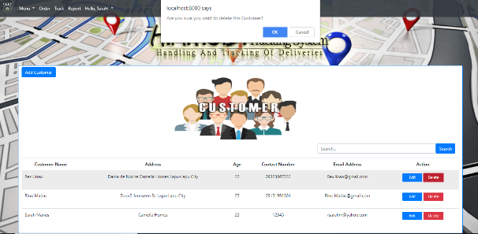

16. To add a new personnel, access the Menu dropdown list and click Personnel. The admin will be redirected to the Personnel’s Page.

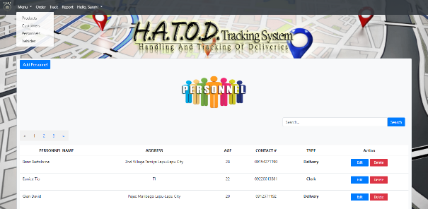

17. Clicking the “Add Personnel” button, displays a modal form that allows an admin to input a new personnel. The input fields in the form are all required.

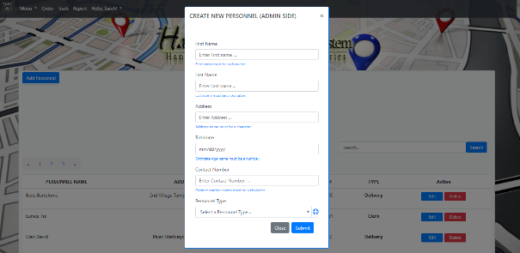

18. An admin can also add a new personnel type. After adding a new personnel type, a validation message will be displayed.

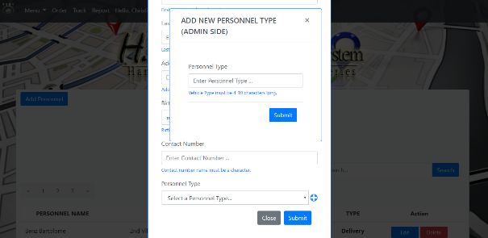

19. An admin can edit a personnel’s information. After editting, a validation message will be displayed.

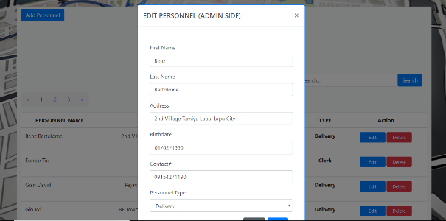

20. An admin can also delete a personnel.

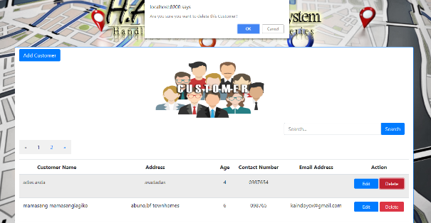

21. To add a new vehicle, access the Menu dropdown list and click Vehicles. The admin will be redirected to the Vehicle’s Page.

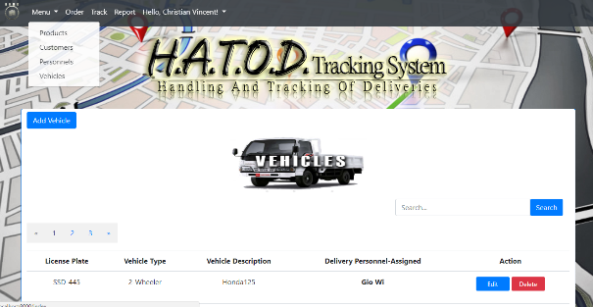

22. Clicking the “Add Vehicle” button, displays a modal form that allows an admin to input a new vehicle. The input fields in the form are all required.

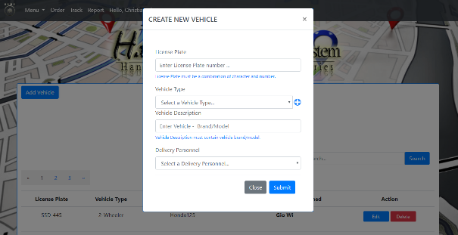

23. An admin can also add a new vehicle type. After adding a new product, a validation message will be displayed.

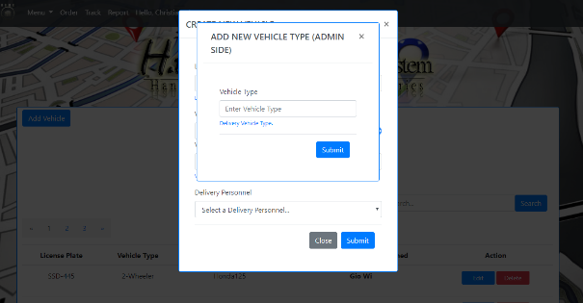

24. An admin can edit a vehicle’s information. After editting, a validation message will be displayed.

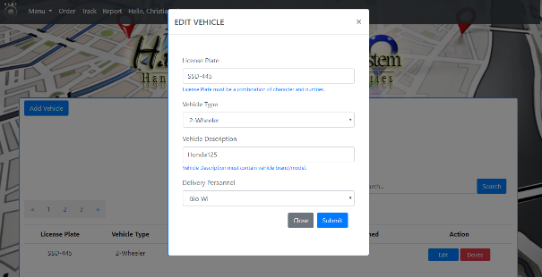

25. An admin can also delete a vehicle.

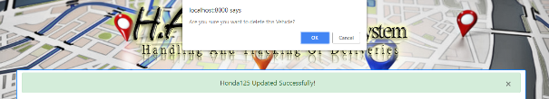

26. To add a new order, access the navigation bar and click the “Orders” button. It will redirect the admin to the Order’s Page.

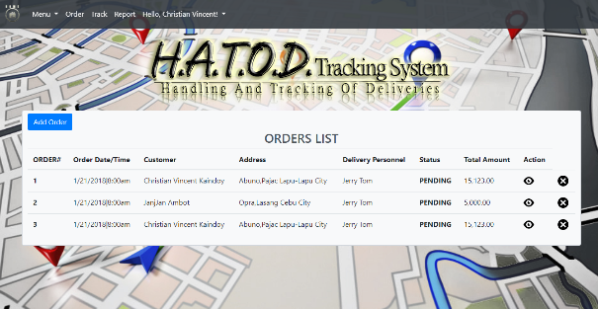

27. Clicking the “Add Order” button redirects the admin to the Order’s Form page.

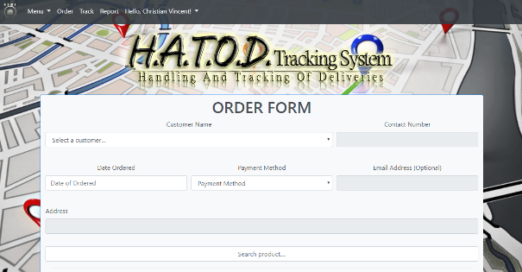

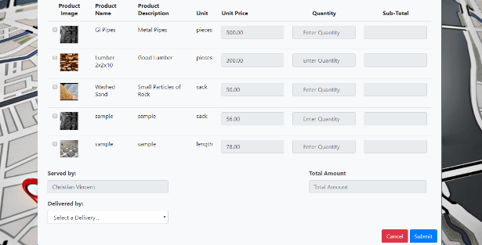

28. After successfully adding an order, the newly added form will be added on the Reports page. To access the Report’s page, go to the navigation bar and click the Reports button.

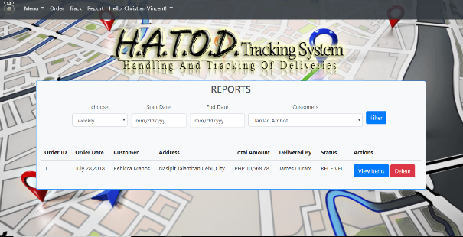

29. On the Report’s Page an admin can view the details of the transaction, and/or cancel a transaction.

30. On the navigation bar, an admin can also view his/her account which contains all his/her information.

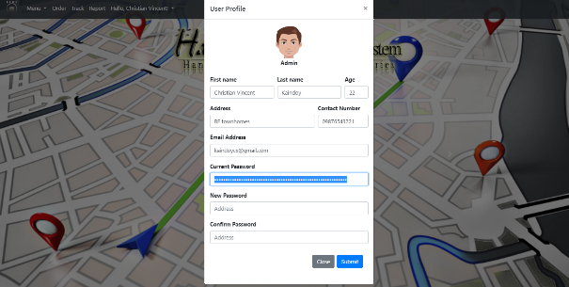

**CLERK ACCOUNT**

1. To login a clerk account, use the credentials given by the admin.



2. 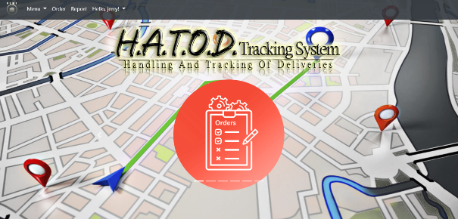After logging in, the clerk will be redirected to a landing page, which is the Dashboard.

3. Accessing the Navigation Bar will allow the clerk to Add Customer, view reports and view clerk’s profile.

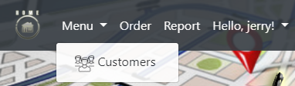

4. To Add Customer, Click Customer in the Dropdown Menu List and click Add Customer. The clerk will be redirected to the Customer Page.

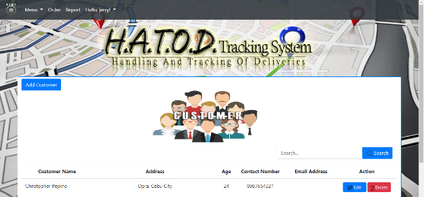

5. Clicking the “Add Customer” button, displays a modal form that allows a clerk to input a new customer. The input fields in the form are all required.



6. The clerk can edit a customer’s information. After editting, a validation message will be displayed.



7. The clerk can also delete a customer.



8. To add a new order, access the navigation bar and click the “Orders” button. It will redirect the clerk to the Order’s Page. The clerk will be redirected to the Order Form Page



9. Clicking the “Add Order” button redirects the clerk to the Order’s Form page.To create order, Click Order in the Navigation Bar and click Add Order.





10. After successfully adding an order, the newly added form will be added on the Reports page. To access the Report’s page, go to the navigation bar and click the Reports button.



11. On the navigation bar, the clerk can also view his/her Account which contains all his/her information.

